Case Study Description: Transporting perishable products
The case study considers a simplified IoT-Enhanced BP in the domain of cold-chain logistics for perishable products, where maintaining appropriate environmental conditions during transportation is critical to ensure product quality and safety. The process begins when a pallet of products arrives at a distribution facility and is registered in the system through a message event. Following this, a worker performs a manual inspection task, during which basic information about the package is recorded, including its identifier and inspection timestamps. Once the inspection is completed, the pallet is transported to its destination.
During transportation, the package is continuously monitored by an IoT temperature sensor, which records environmental conditions over time. These measurements are made available via a sensor that publishes timestamped temperature data in CSV format to a Cloud-supported RabbitMQ message broker on the ‘temp’ exchange. For the purposes of this exercise you can consider it is deployed in the host http://localhost, using the AMQP protocol, and the following timestamp pattern: yyyy-MM-dd HH:mm:ss.
At the end of the process, a decision is made via an exclusive gateway to determine whether the product pallet is in a saleable condition. This decision is based on both the inspection results and the environmental conditions experienced during transport.
The goal of the case study is to define an ML-based predictive model that determines whether a product pallet meets compliance requirements. To support this, relevant data must be extracted and transformed into a dataset. In particular, four key aspects are considered: (1) the duration of the manual inspection, (2) the duration of the transportation task, (3) the average temperature during transport, and (4) the final outcome of the saleable condition evaluation.
The process defined in BPMN is the following. It is executed in a Camunda Server available in the host http://localhost:8080/engine-rest. The id of the process is “PalletProcessing”, data is provided in JSON format and the timestamp used by this engine matchs the following pattern “yyyy-MM-dd'T'HH:mm:ss.SSSZ”.
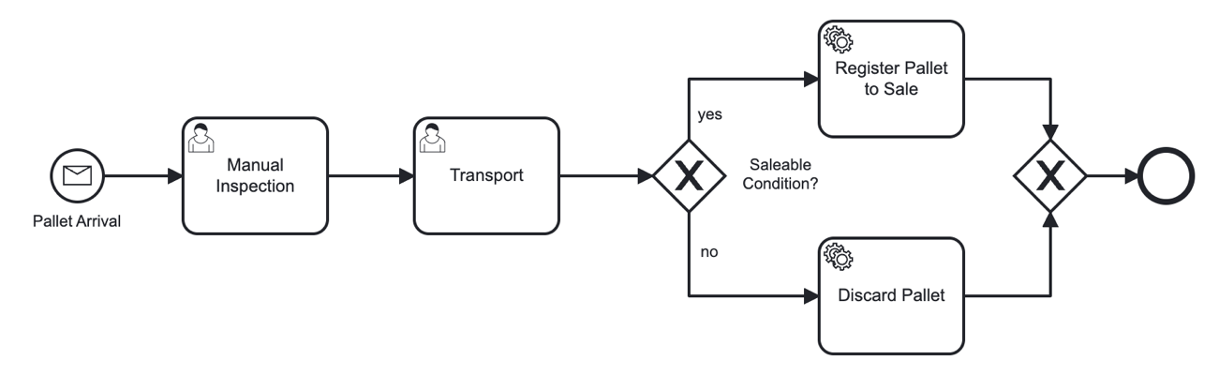
Required BPMN elements Ids:
- Start event: palletArrivalMsg
- End event: end-event
- Tasks: inspectionTask, transportationTask
- Gateway: complianceGateway
Using the DSL, perform the following tasks:
- Define the required Process and IoT Data Sources
- Define features required to construct a dataset.
- Define a classification model predicting whether the package is compliant. Use a Random Forest algorithm with a max_depth of 15 and a number of trees (n_estimators) of 250.

